ROLL:21l-5654

Muhammad Hamza khan

TASK 1:

Q1:

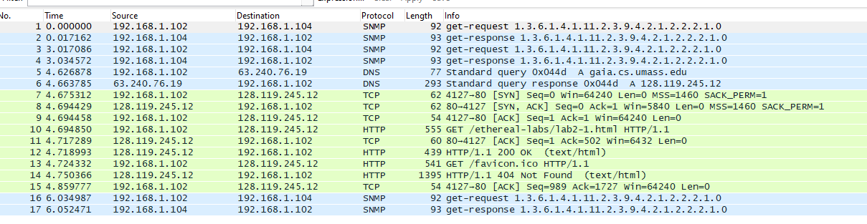

Protocol = SNMP,TCP,HTTP,DNS

Q2:

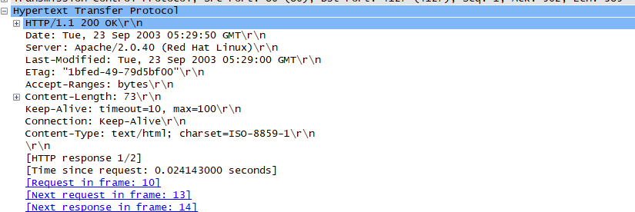

Time request is 0.024143000 seconds to get Ok Get response.

Q3:

No, the second response was not successful,as it delivers 404 not found:

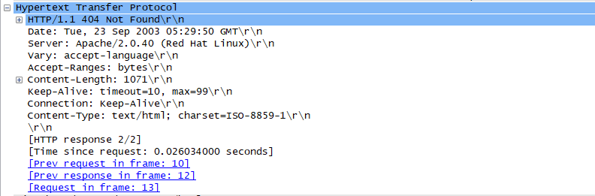

Q4:

Browser running HTTP version is 1.1



Q5:

Language : en-us

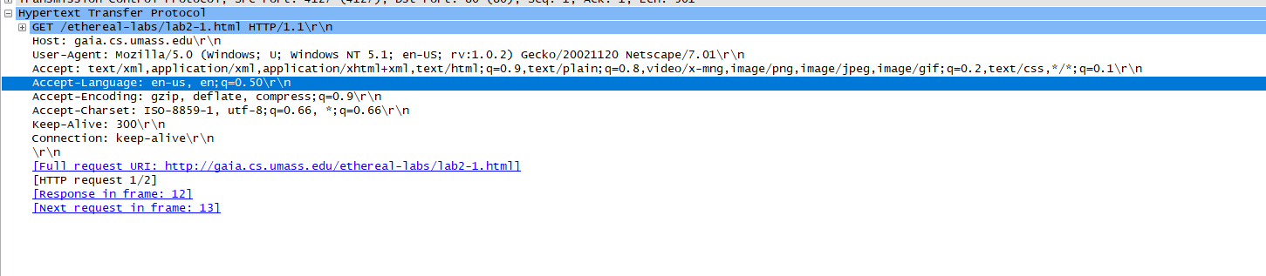

Q6: IP Address

My computer: 192.168.1.102

Gaia.cs.umass.edu : 63.240.76.19





Q7:MAC Address:



My computer: DellComp_4f:36:23

Server: Linksysg_da:af:73

Q8:PORT

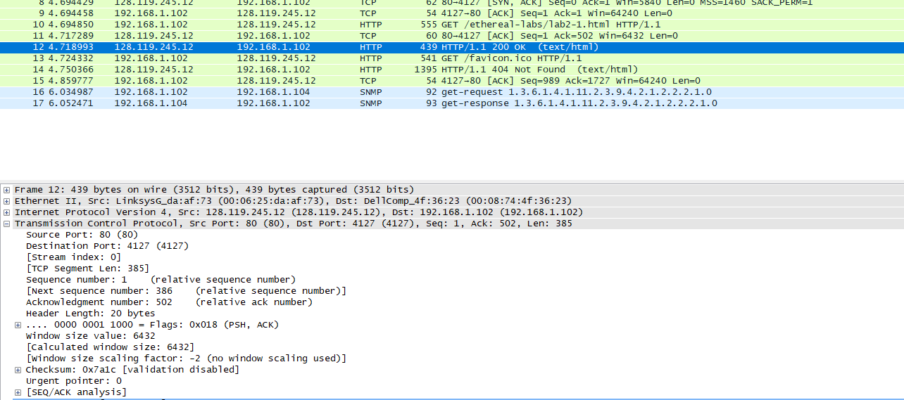

PORT number:80

Port 80 is the default network port for web servers using HTTP.

Q9: Status code:



Status code from browser : 200,404

Q10:

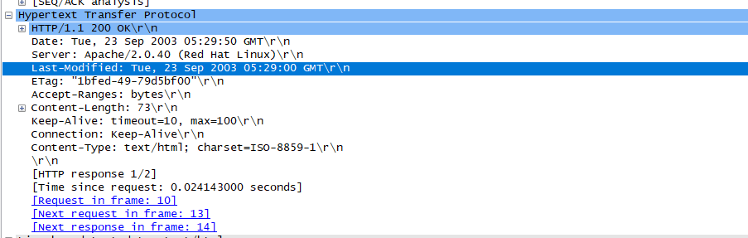

Q11:

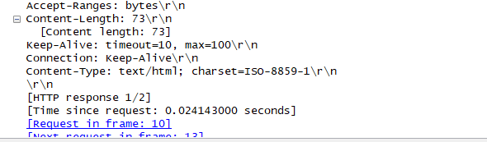

TASK 2:

Q1:

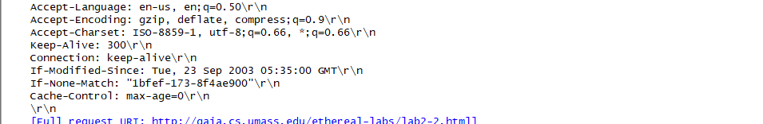

Q2:

Content:

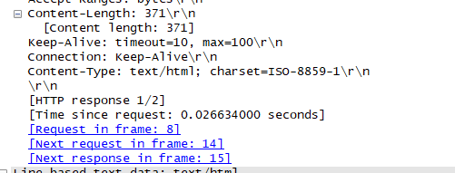

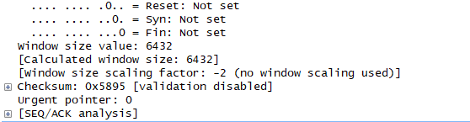

Packet bytes window=6432

Q3:

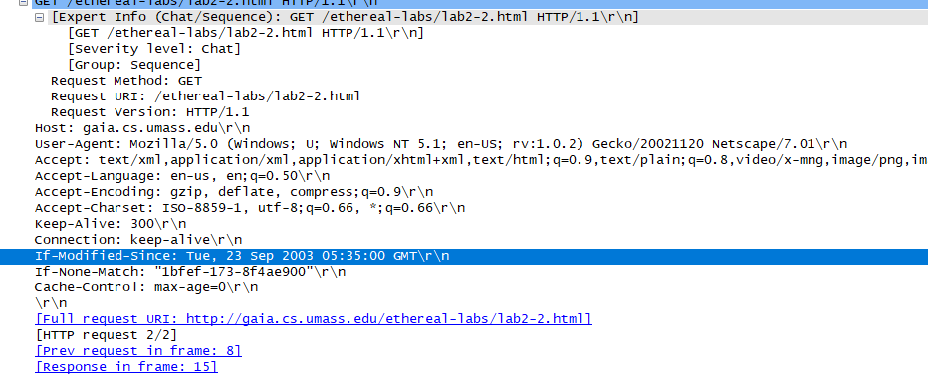

An “IF-MODIFIED-SINCE:” line in the HTTP GET represent the information that was the date it was modified, a match query, and a cache-control so cache has to be cleared first.

Q4:

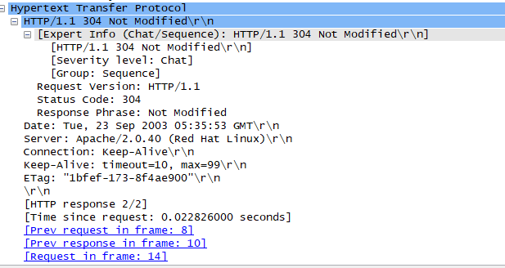

IT is not modified,so data is not explicitly sent

LAB STATEMENT 2:

1. How many HTTP GET request messages did your browser send?

Ans: 1 request message

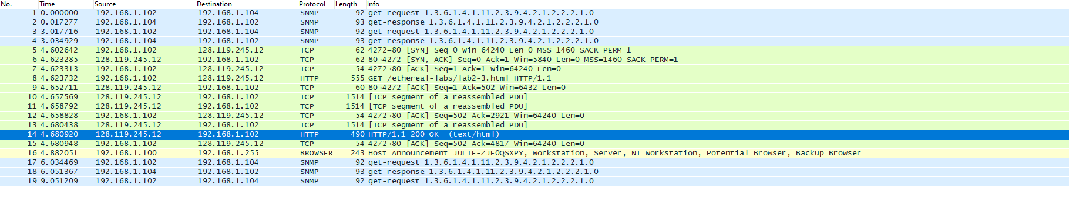

1. Packet number 8

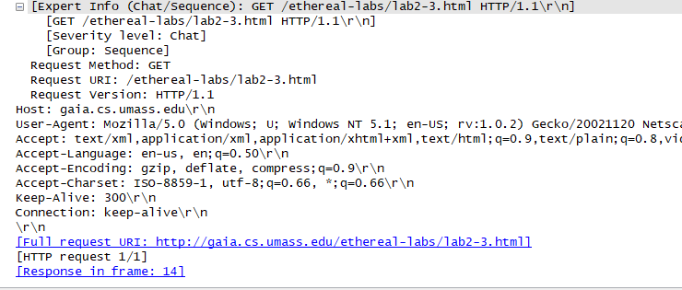

1. PACKET number 10
2. Status code:200

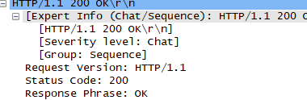 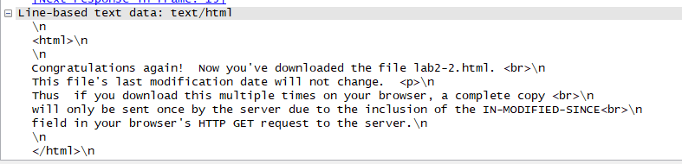

1. Number of packets 10,11,13,14

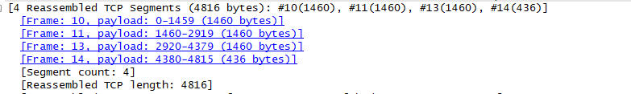

Lab Statement 3:

Content length = 4500

Packets = 4

Max transmission limit = 490

Total add upto 4816 bytes